**LECTURE 6 – Strings1 - PROBLEMS**

Two strings of characters with the same length are given in data segment: a and b. Combine the elements from the both string and create a new string D in next way: on a first position from D is the element from the last position from string a and on the second position from D is the last element from string b and so on:

a=’a’, b’,’c’

b=’A’, ‘B’, ‘C’

* D = ‘cCbBaA’

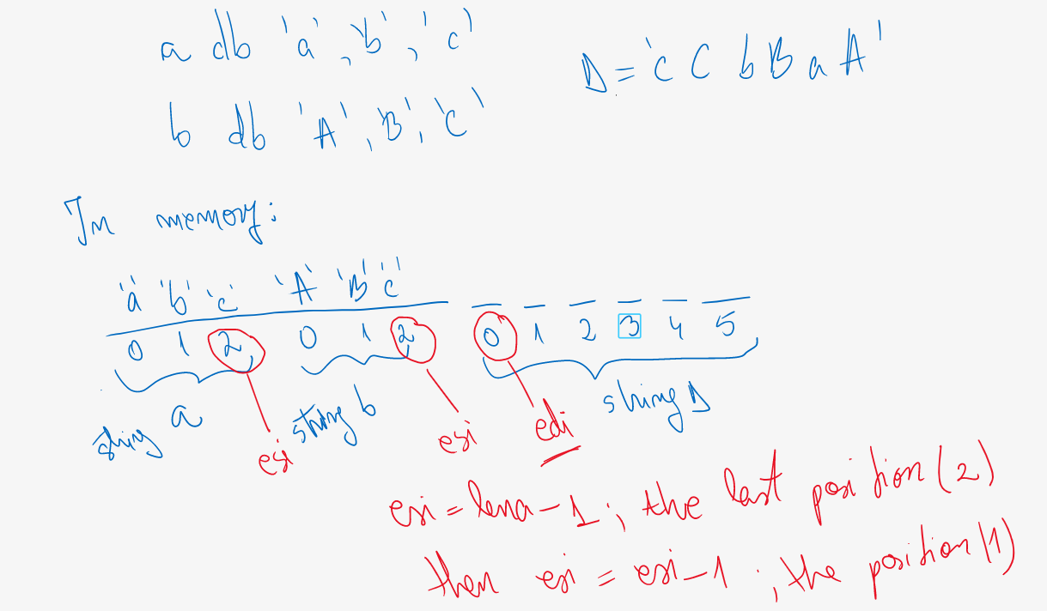

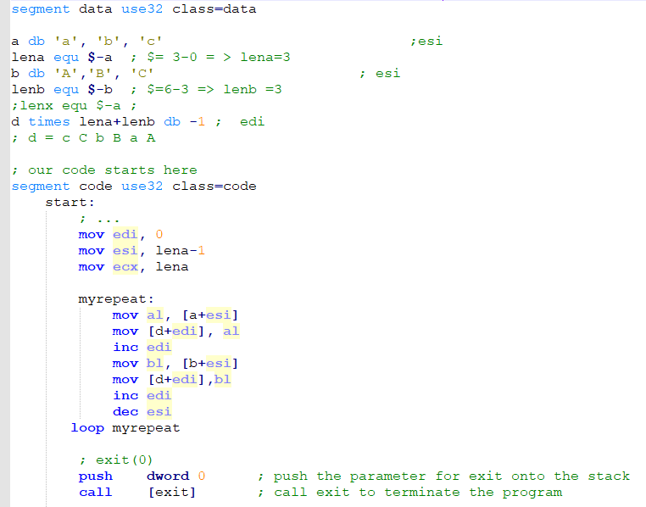

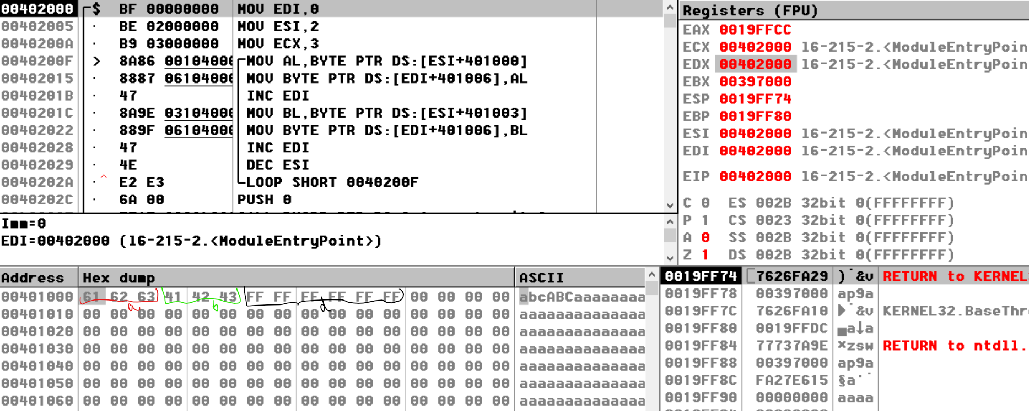

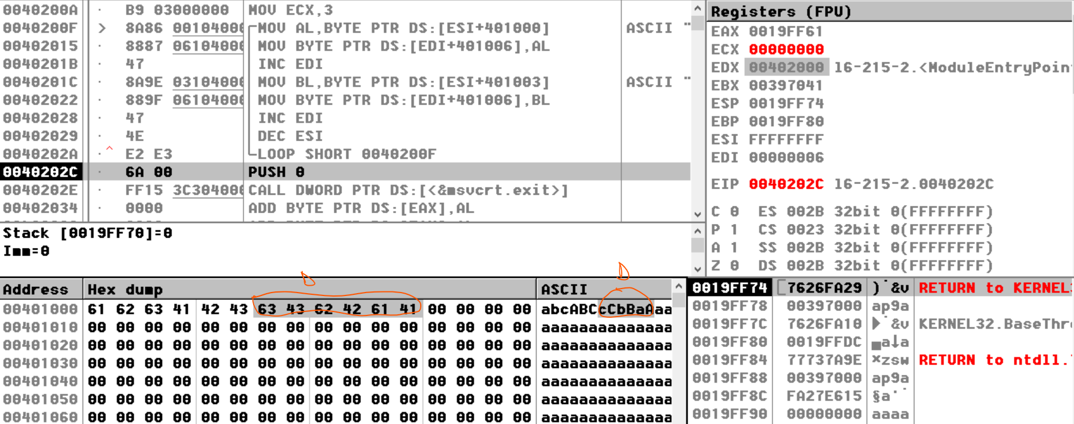

A string of words is given. Create two new other strings: L – string of low bytes from each word from s and H – string of high bytes from each word from s.

